The University of Azad Jammu and Kashmir, Muzaffarabad

Name: Alishba Zakir
Roll No: 2024-SE-02
Course: DataBase Systems
Course Code: CS-2204
Lab: 10
Submitted To: Engr. Awais Rathore
Submitted By: Alishba Zakir
Date: May , 2026

Department Of Software Engineering

Scalar Function :
A scalar function in a database is a built-in or user-defined function that takes one or more input values and returns a single, individual value. Unlike aggregate functions (like SUM or AVG), which operate on a collection of rows to return a summary, a scalar function operates on
individual values in each row
String functions in a database are built-in tools used to manipulate, clean, format, and analyze text data. Database engines like MySQL, PostgreSQL, SQL Server, and Oracle provide these functions to allow developers to perform operations on string columns directly within queries.
Create Table :
- Customer
- Product

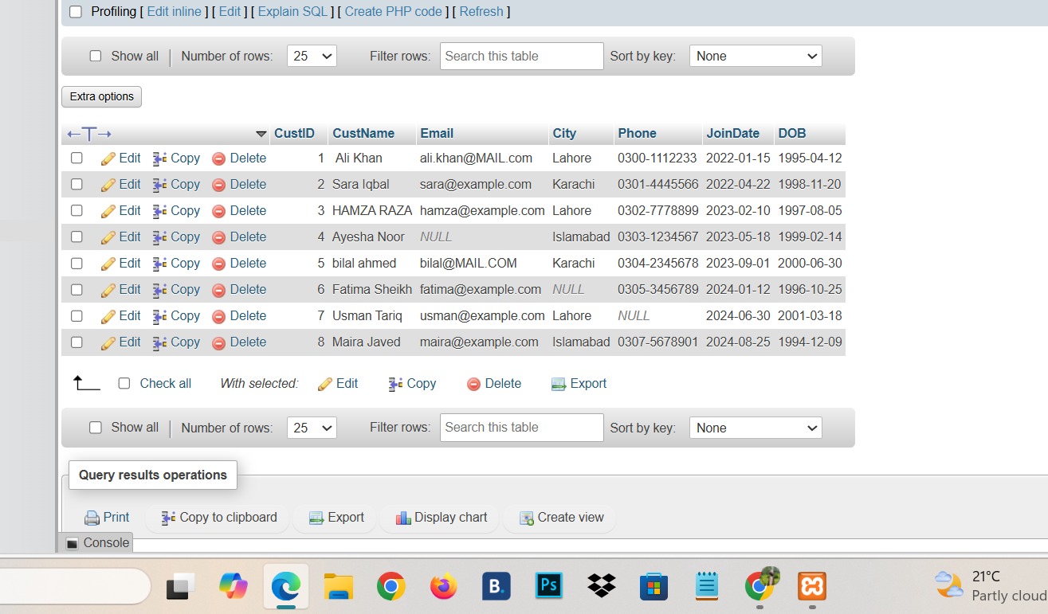

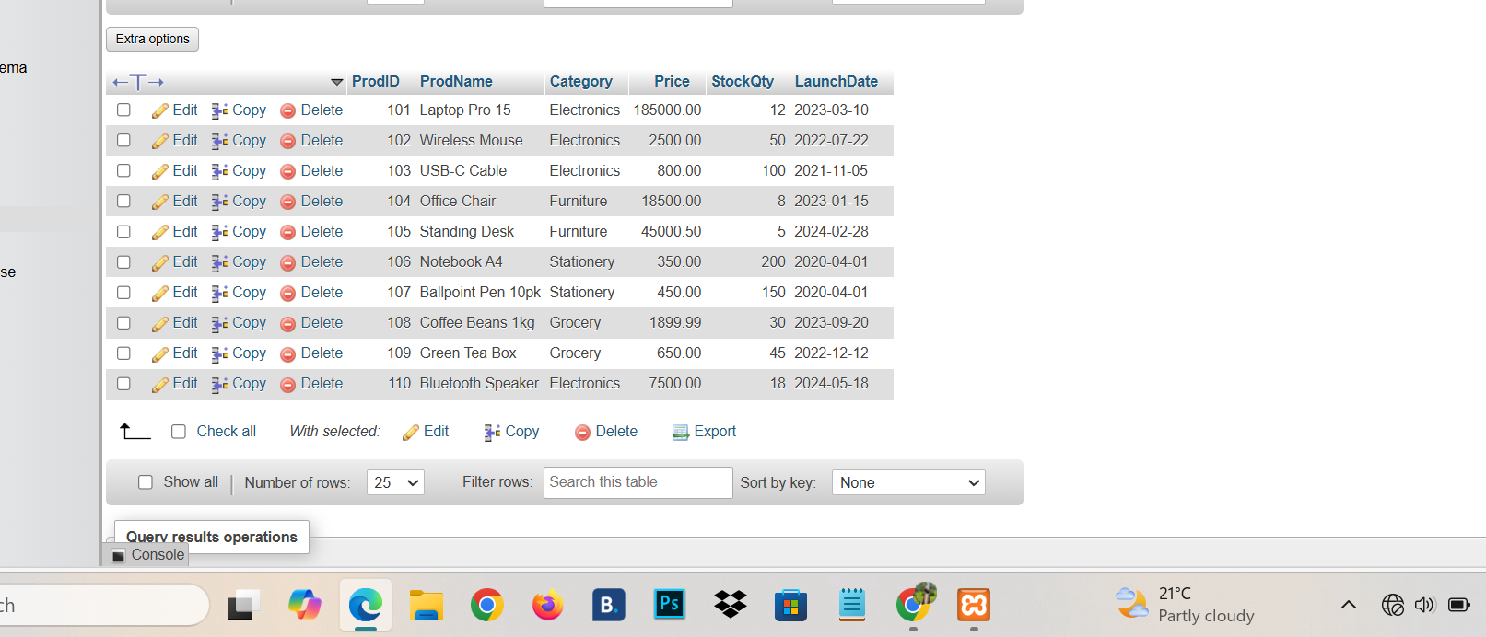

PartA: String Function :
A1: Remove Spaces :
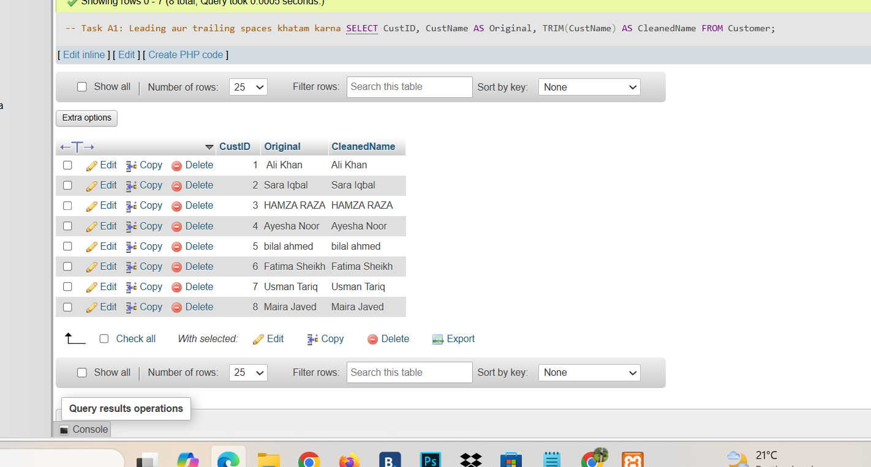
A2: Uppercase& lower Case:
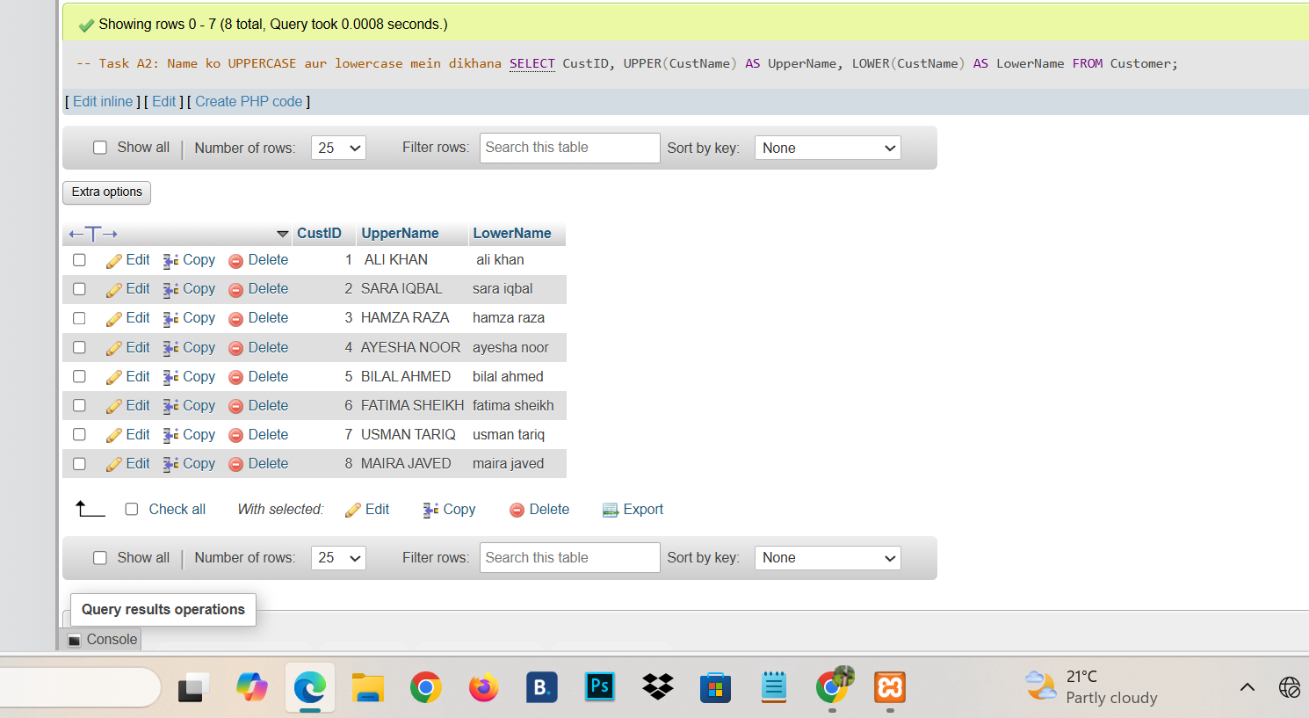
A3: Name+Character Count :
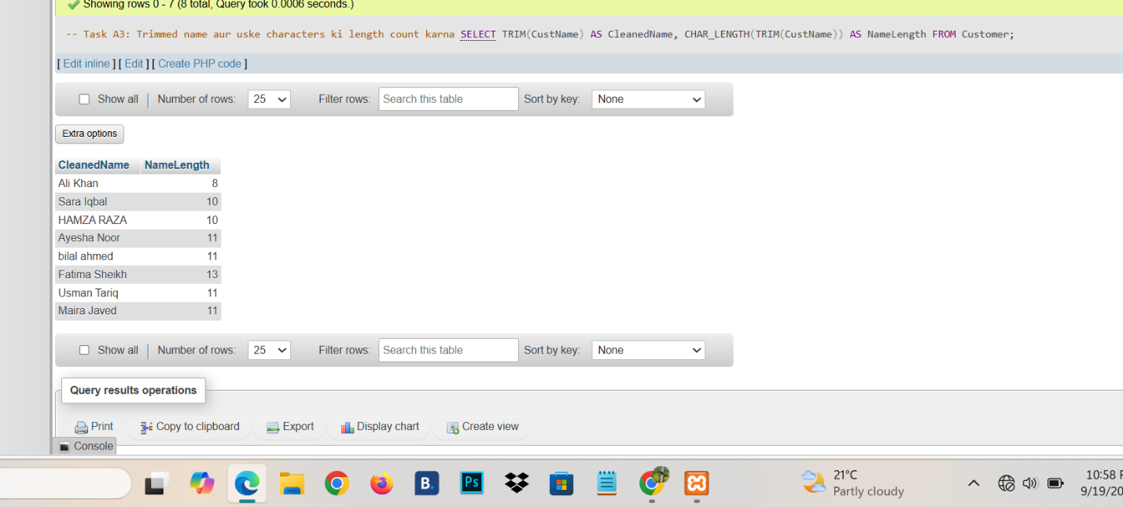
A4:Greeting :
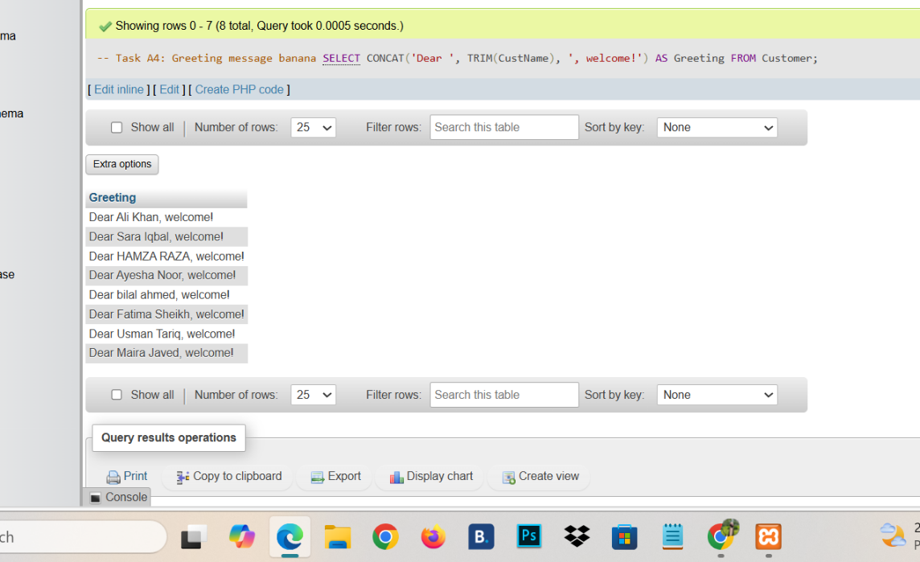
A5: Email Username :
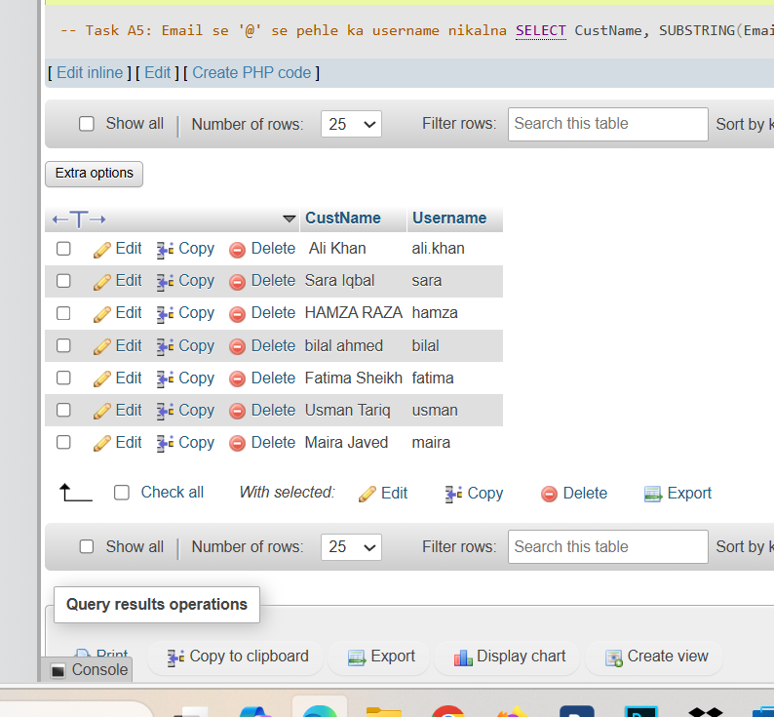
A6: Email domain:
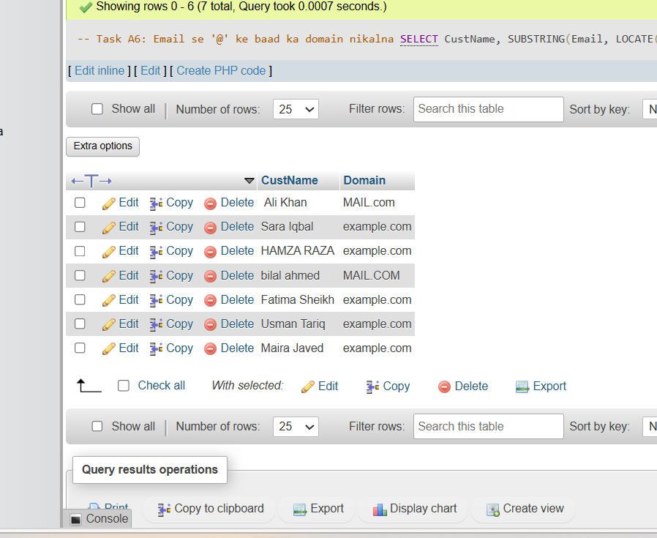
A7: First 3 Character : 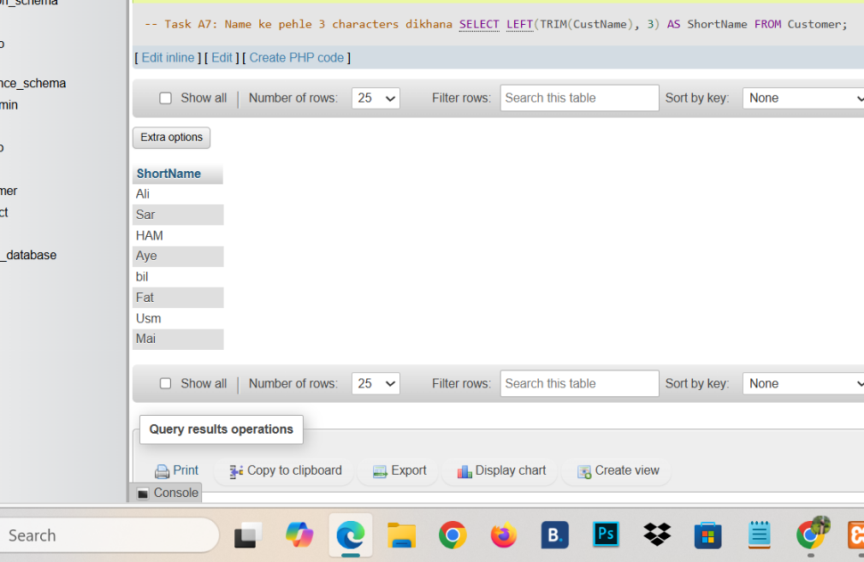
A8: Mask Phone Number:

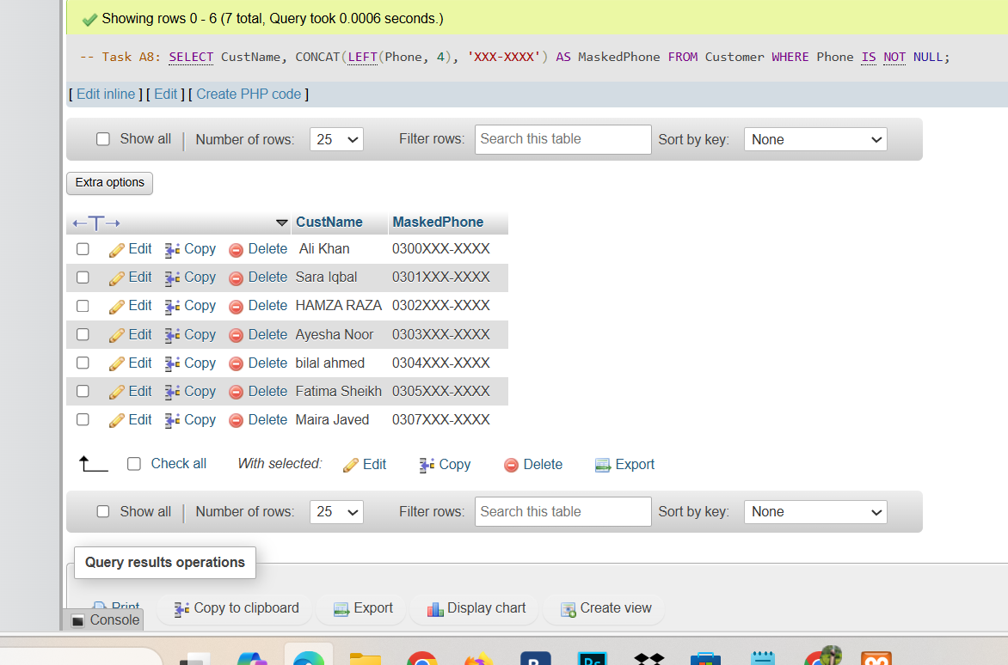
A9: Replace Spaces With Hyphens:

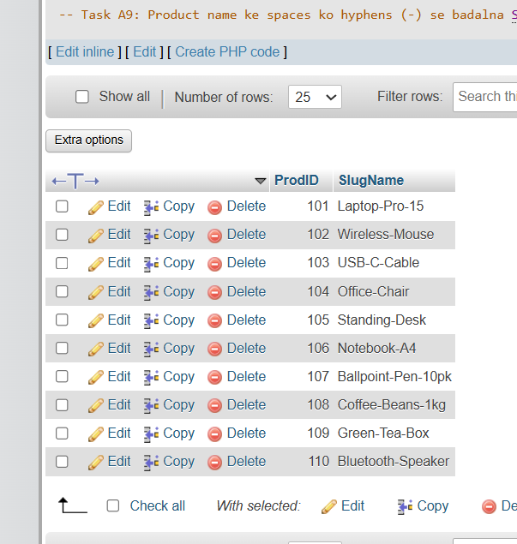
A10: Pad Product ID:

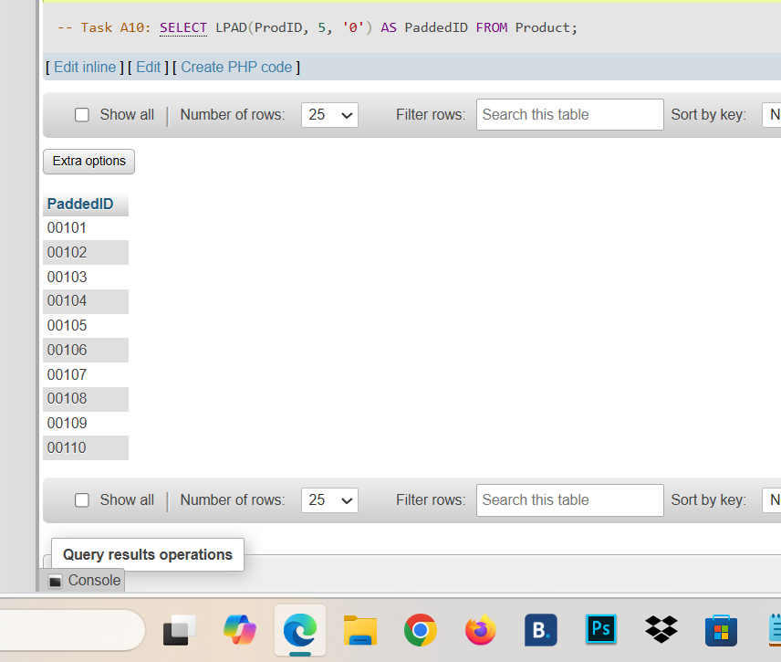
A11:Final Product Contaning “Pro”:
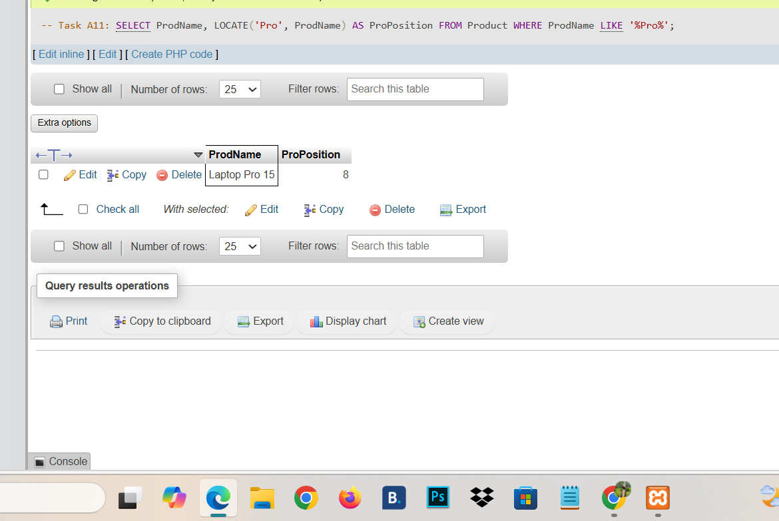
A12:First Name only:

